**Software Requirement Specification**

***Tolexo Online Industrial Shopping***

**Overall Description:**

**Tolexo** Online Industrial Shopping (TOIP) application is a shopping destination for online shopping of electrical equipment & industrial goods like office supplies for new setup or safety equipment for workers or some hand tools. Tolexo enables suppliers to set up online shops, industrial customers to browse through the shops, and a system administrator to approve and reject requests for new shops and maintain lists of product categories. The online shopping system will use the internet as the sole method for selling goods to its consumers.

**Product Perspective:** This product aimed towards industries who are looking for bulk purchases and don’t want to visit the shop as they might not get time for that or might not be interested in visiting there and dealing with lot of formalities.

**Product Functions:**

Various functional modules implemented by the system will be :

* ***Product Display***

If the industrial customer wants to buy any product, they can browse through various products displayed under various product categories like Safety, Electricals, Hand tools, Power tools, Test & Measure, Office Supplies.

* ***Get quick quote from supplier***

The industrial customer can select a product and ask for quick quote from the supplier for bulk purchase

* ***Confirmation of Order***

Once the industrial customer confirms their order, based on the quote received from supplier, the order will be placed.

* ***Payment***

In this system we are dealing with different mode of payment like credit card, debit card, Net banking and Cash on Delivery

* ***Logout***

After ordering or surfing for the product customer has to logout.

* ***Report Generation***

After ordering for the product, the system will sent one copy of the bill to the customer’s Email-address and another one for the system data base.

**Non-Functional Requirements:**

Following Non-Functional Requirements should implement the following on the availability of the internet connectivity.

(i) Secure access to consumer’s confidential data.

(ii) 24X7 availability.

(iii) Better component design to get better performance at peak time.

(iv) Flexible service based architecture will be highly desirable for future extension.

Various other Non-Functional Requirements implemented in this system are:

➢ Security

➢ Reliability

➢ Maintainability

➢ Portability

➢ Extensibility

➢ Reusability

➢ Compatibility

➢ Resource Utilization

**Steps to follow :**

1. The User visit on [www.tolexo.com](http://www.tolexo.com) site.
2. The portal displays the home page.

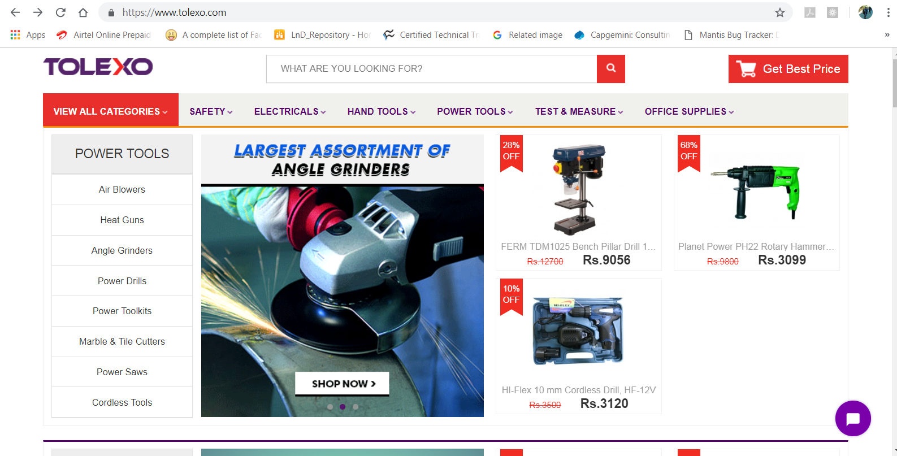

1. The user click on any of the product link. The portal displays ‘Request for bulk price’

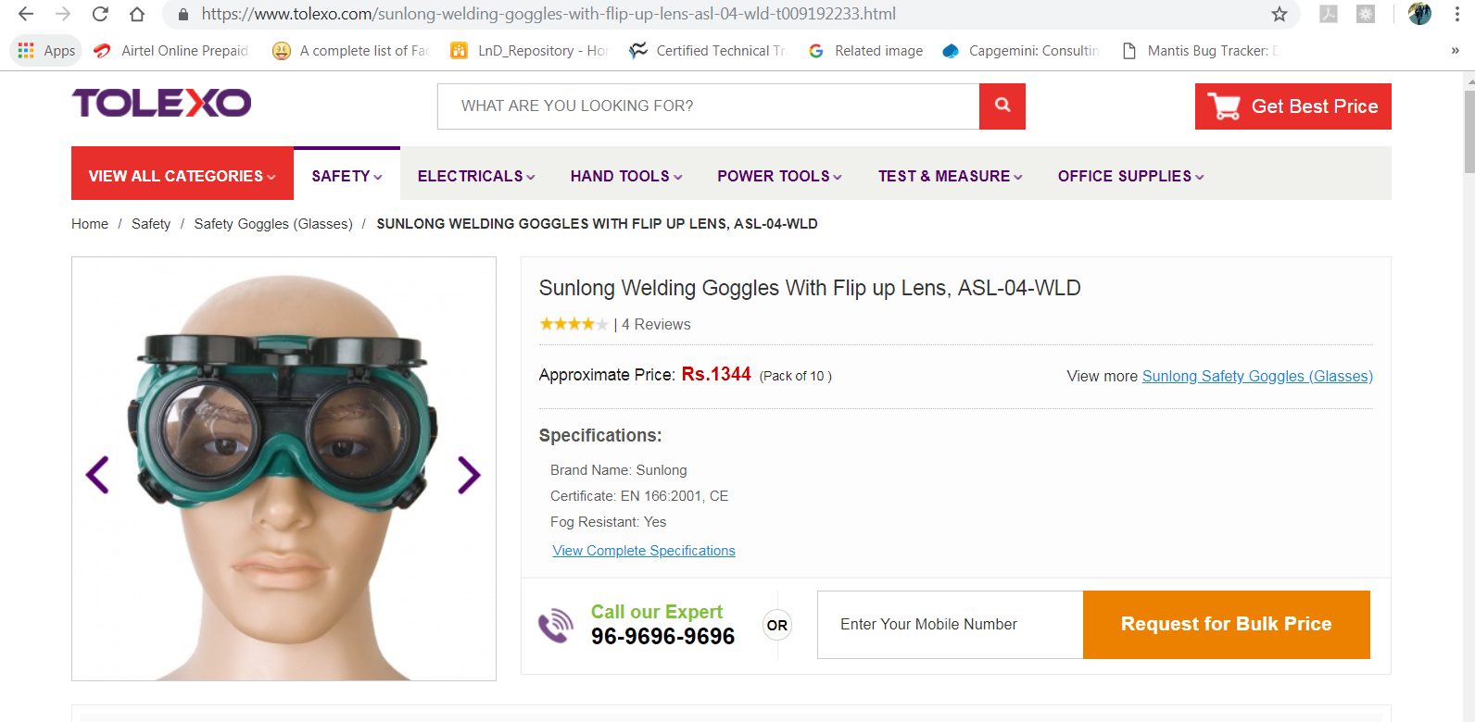

1. The user clicks on the ‘Request for bulk price’ button. It displays the following screen for getting basic details

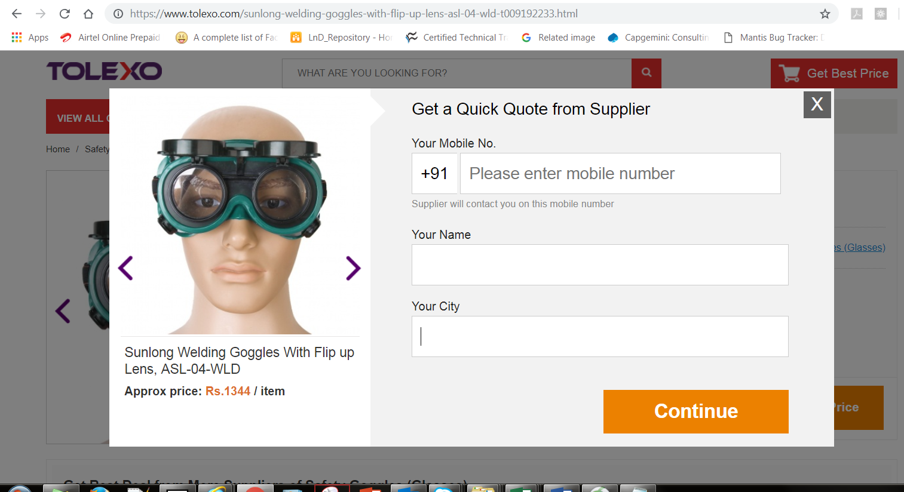

1. The user clicks ‘Continue’ button and the following screen is displayed for getting a quick quote from supplier.

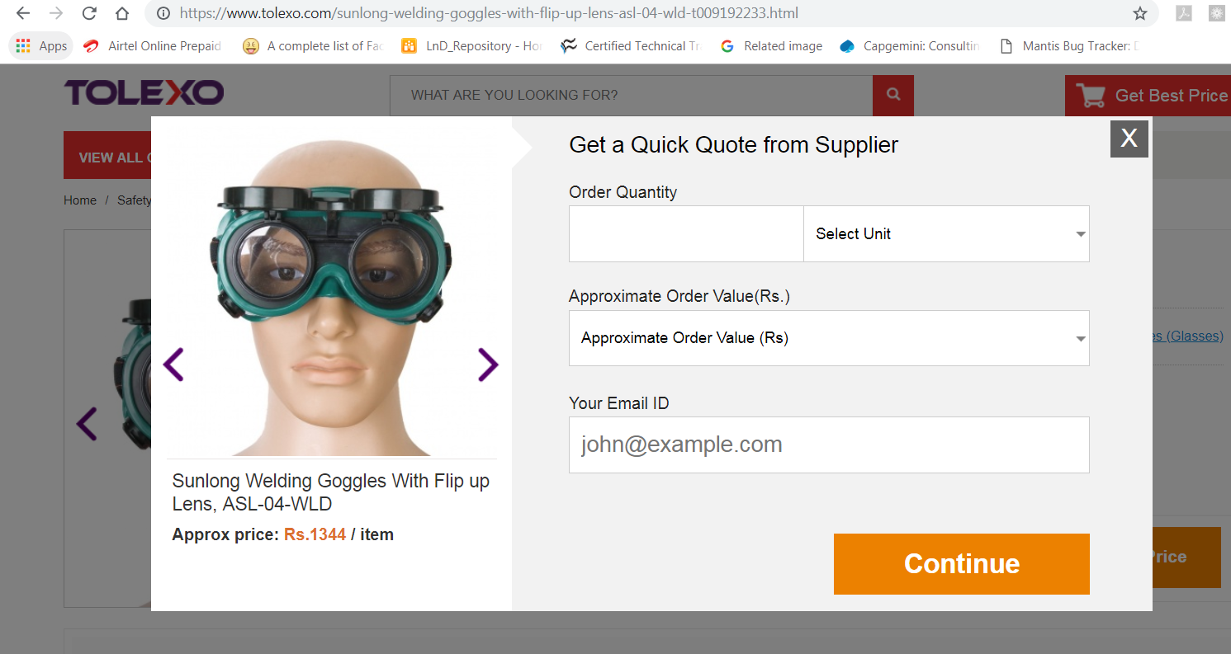

1. The user provides order details and clicks on ‘Continue’ button and the following screen is displayed for giving additional details if any.

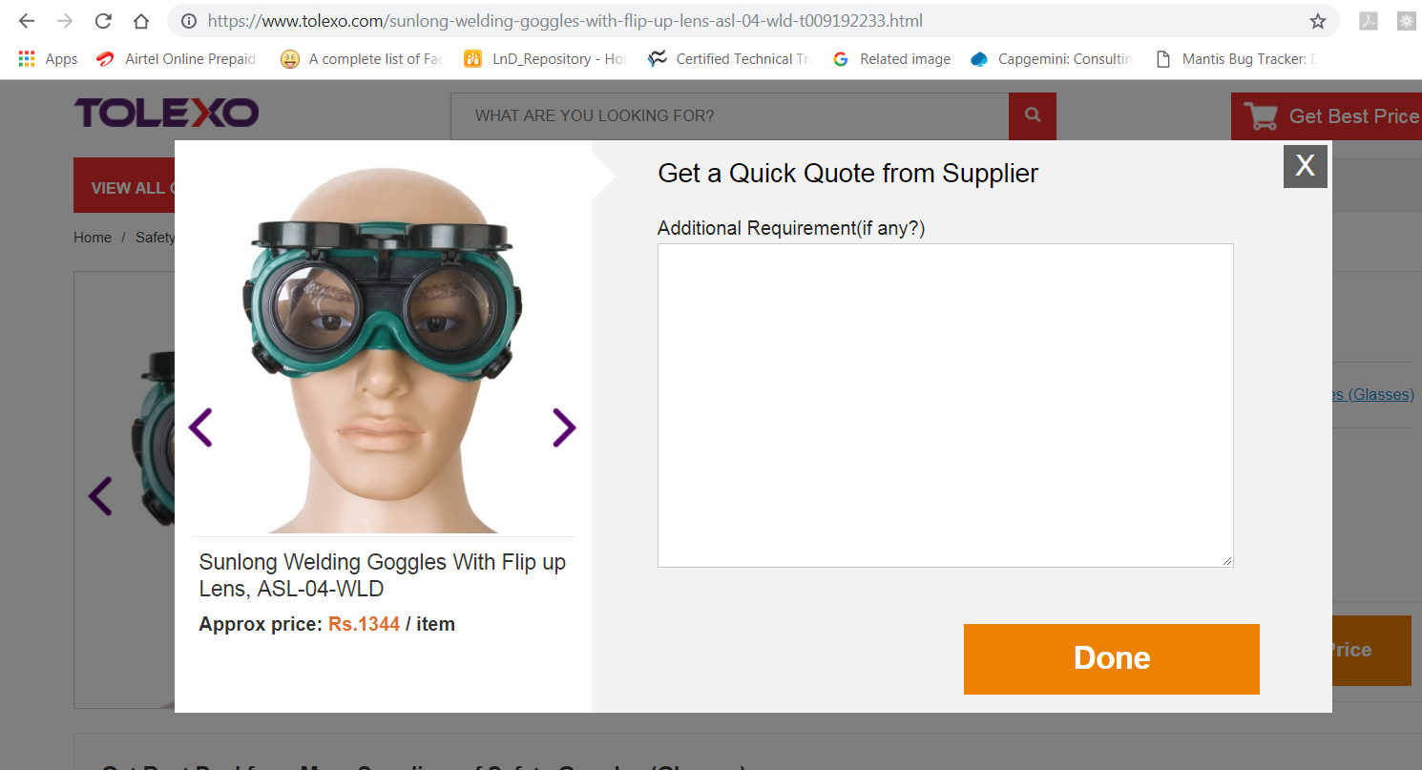

1. The user provides additional details, if any and clicks on ‘Done’ button, which displays a confirmation message.

Business Rules for ‘Submitting a quote’ page.

|  |  |
| --- | --- |
| **Fields** | **Description** |
| Your Mobile Number | It must be equal to 10 digits and accept only numbers |
| Your Name | Name should accept only alphabets.  Name length should be 3 to 30 characters. |
| Your City | It should accept only characters. Cities allowed are Chennai, Mumbai, Bangalore, Pune |
| |  |  | | --- | --- | | Order Quantity |  | | It should accept only numbers. Maximum value is 1000. Minimum value is 20. |
| Select Unit | It should display options like nos, kilograms, pieces, tons etc |
| Approximate Order Value | It should be a list box. It should have options for ‘upto 1000’ and ‘above 1 crore’ |
| |  |  | | --- | --- | | Your Email ID |  | | Should accept only valid and existing email. |